TOPICS COVER :
Unit I
- Introduction to human body
Definition and scope of anatomy and physiology, levels of structural organization and body systems, basic life processes, homeostasis, basic anatomical terminology.
- Cellular level of organization
Structure and functions of cell, transport across cell membrane, cell division, cell junctions. General principles of cell communication, intracellular signaling pathway activation by extracellular signal molecule, Forms of intracellular signaling: a) Contact-dependent b) Paracrine c) Synaptic d) Endocrine
- Tissue level of organization
Classification of tissues, structure, location and functions of epithelial, muscular and nervous and connective tissues.

Human Anatomy and Physiology - I
Chapter 1: Introduction to Human Body
Definition and Scope of Anatomy and Physiology
- Human Anatomy and Physiology (HAP): The study of the structure and functions of the human body.
- Anatomy: The branch of science that deals with the study of the structure of different organs and body parts of the human body.
  - Examples: Atrium, ventricles, aorta of the heart.
  - Histology: Study of tissues.
- Physiology: The branch of science that deals with the study of the functions of different organs and body parts of the human body.
  - Example: Blood circulation in the heart.
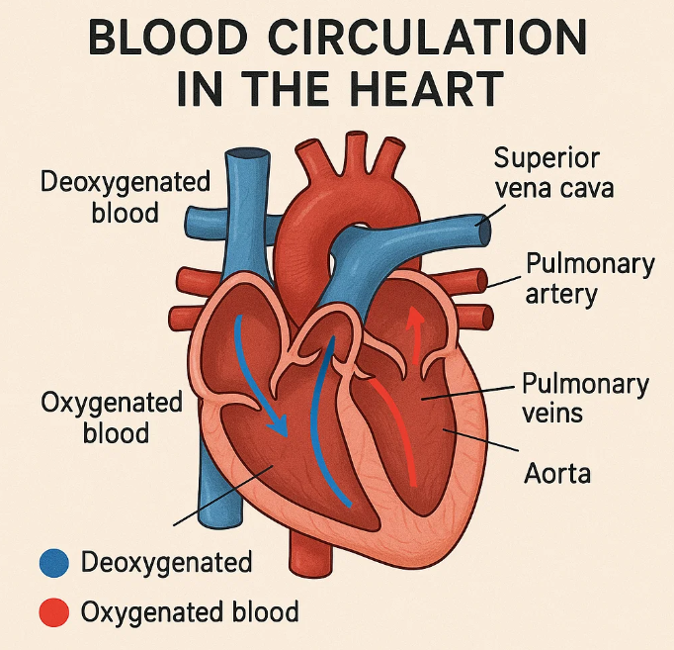
  - Neurophysiology: Study of neurons.
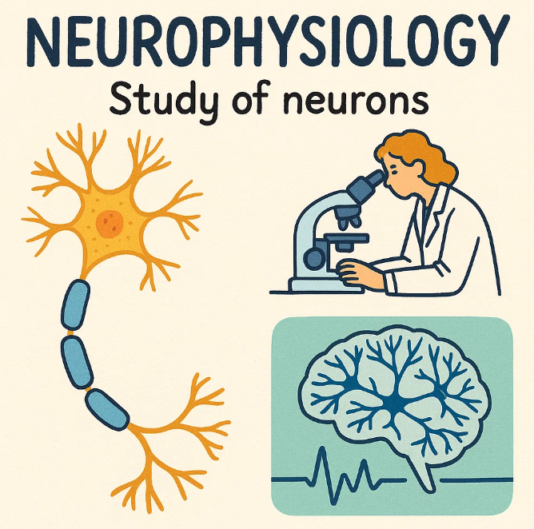

Scope of Anatomy & Physiology
The scope of Anatomy & Physiology includes:
- Study of structure and function of body parts.
- Understanding parameters of normal health such as temperature, pH, and basic needs.
- Pathology of disease.
- Surgery techniques.
- Human evolution and development.
Levels of Structural Organization
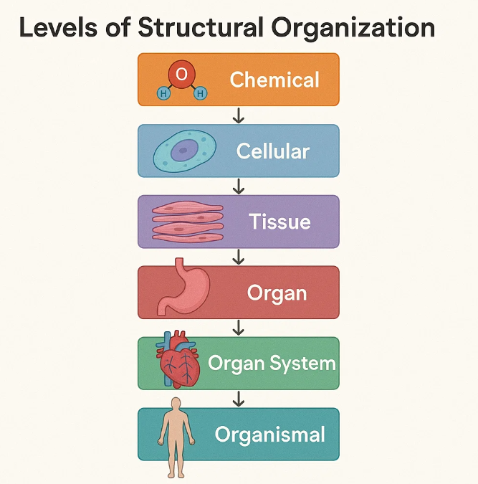
The human body has six levels of structural organization:
- Chemical/Molecular Level: The most basic level where two or more atoms or molecules join together to form cells.
  - Examples: Oxygen (O), Carbon (C), Hydrogen (H).
- Cellular Level: The basic structural and functional level of the body. Two or more cells joined together form tissue.
- Tissue Level: Groups of cells that work together to perform particular functions.
  - Examples: Nervous tissue, epithelial tissue, skin.
- Organ Level: Different types of tissues combine to form organs that perform proper body functioning.
  - Examples: Heart, lungs, kidney.
- System Level: A group of organs combine to form a system.
  - Examples: Digestive system, respiratory system, cardiovascular system.
- Organism Level: The highest level, a complete body made up of combined systems.
  - Example: Human body.
Body Systems
A system is a group of organs that combine to perform proper functioning. There are 11 systems in the human body:
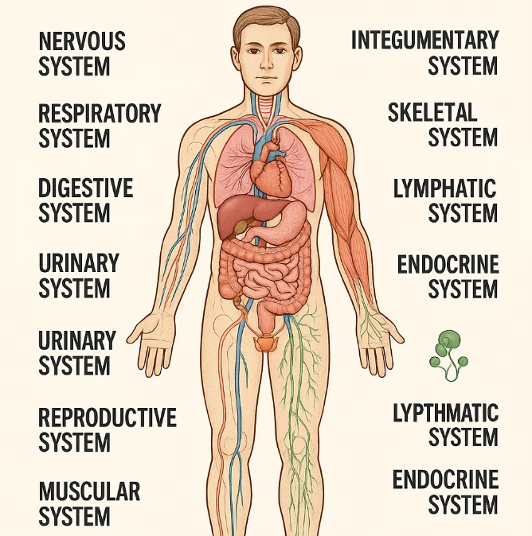
- Nervous System: Coordinates all body actions, responsible for voluntary and involuntary actions, and signalling.
  - Organs: Brain, spinal cord.
- Respiratory System: Involved in the exchange of oxygen (O2) and carbon dioxide (CO2).
- Cardiovascular System: Responsible for the circulation of blood in the body, also known as the circulatory system.
  - Organs: Heart, blood vessels, blood.
- Digestive System: Responsible for the digestion of food and absorption of nutrients.
  - Organs: Mouth, stomach, intestine.
- Urinary System: Responsible for blood filtration and waste removal.
  - Organs: Kidney, urethra, bladder.
- Reproductive System: Responsible for the production of offsprings.
  - Organs: Testes, ovary, fallopian tube.
- Integumentary System: Also known as the exocrine system, provides protection through the skin and contains glands.
  - Organs: Skin, hair, nails, sweat glands.
- Muscular System: Responsible for the movement of body organs through muscles.
- Skeletal System: Contains bones that maintain structure and provide protection to the body.
  - Organs: Skull, ribs, femur.
- Lymphatic System: Also known as the immune system, it defends the body against pathogens. Consists of a network of lymphatic vessels that carry lymph.
- Endocrine System: Consists of different types of hormones that help in body functioning.
Basic Life Processes
Human bodies perform various functions for survival and growth. All living organisms have specific life processes.
- Metabolism: The sum of all chemical processes occurring in the body.
  - Catabolism: Breakdown of complex chemical substances into simple compounds.
  - Anabolism: Building up of complex chemical substances from small components.
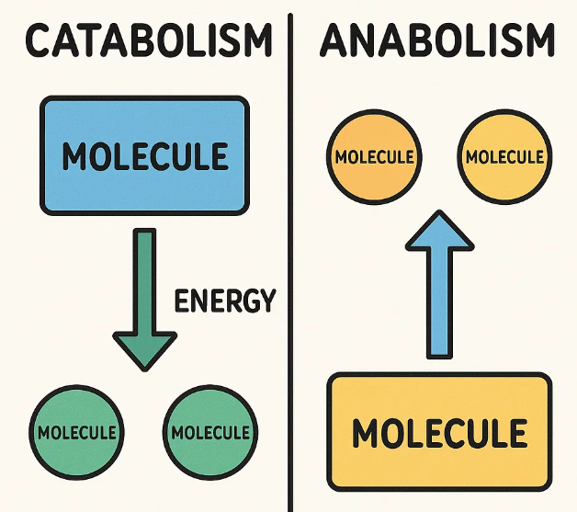
- Responsiveness: The ability of the body to detect and respond to changes.
  - Example: Sensitivity to cold.
- Movement: Includes motion of the whole body and individual organs.
- Growth: The development of the body and increase in body size.
- Differentiation: The development of a cell from an unspecialized to a specialized state.
  - Example: Stem cells generating a complete human body.
- Reproduction: Formation of new cells and production of new offsprings.
- Respiration: Involves the exchange of O2 and CO2 between cells and the external environment.
- Digestion: Degradation of food and large molecules, and absorption of nutrients into the blood.
- Excretion: Removal of waste products from the body.
  - Example: Urination.
Homeostasis
- Derived from two Greek words: "Homo" (same/constant) + "Stasis" (state), meaning "staying the same".
- A condition where the internal environment of the body remains relatively constant despite variations in the external environment.
  - Example: Body temperature at 37°C.
Homeostasis Control Mechanism
All body organs coordinate to maintain homeostasis, primarily controlled by the Neuroendocrine System (Nervous + Endocrine system). It has three components:
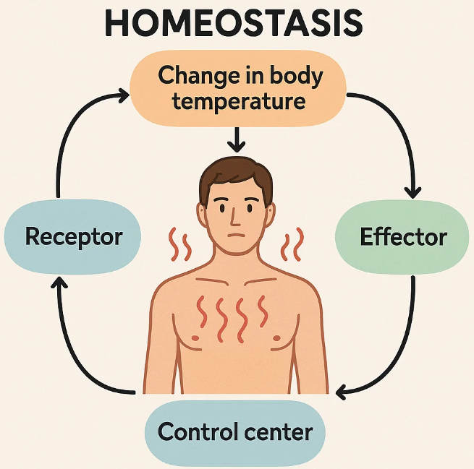
- Receptors: Sensors that receive/detect changes or other stimuli.
- Control Centre: Receives stimuli from receptors and analyzes them.
- Effectors/Feedback System: Takes the internal environment back to its constant state or homeostasis if changes occur.
Types of Feedback Systems:
- Positive Feedback System (+): Used to increase or amplify a change. When something decreases in the internal environment, this system tries to bring it back to normal by increasing it.
  - Example: During childbirth, the release of oxytocin increases uterine contractions to aid in childbirth.
- Negative Feedback System (-): Used to decrease or reverse a change. When something increases in the internal environment, this system tries to bring it back to normal by decreasing it.
  - Example: Temperature regulation in case of fever. Hypothalamus stimulates sweating to decrease body temperature.
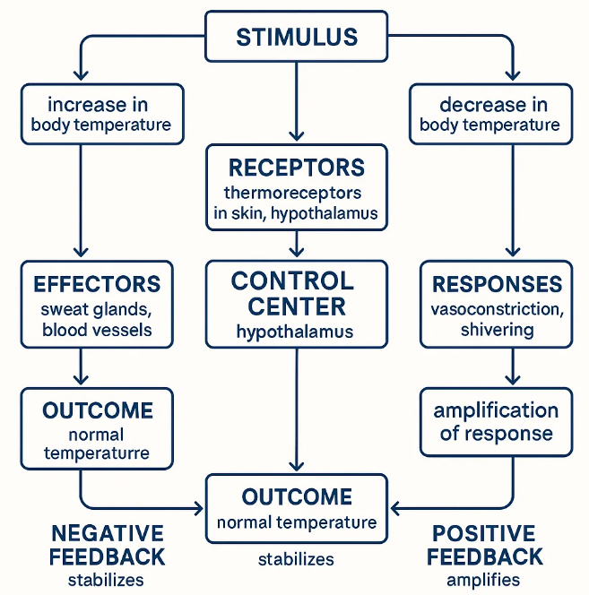
Basic Anatomical Terminology
Divided into three groups:
- Directional Terms:
  - Superior (upper, cranial): Upper part.
  - Inferior: Lower part.
  - Anterior end: Front part.
  - Posterior end: Back side.
- Sectional Planes/Planes of the Body:
  - Sagittal plane: Divides the body into left and right parts.
  - Transverse plane: Horizontal axis parallel to the ground, passes through the body at a 90° angle, and divides the body into two parts (upper and lower).
  - Coronal plane: Divides the body into anterior and posterior parts.
- Body Cavities:
  - Thoracic Cavity.
  - Abdominal Cavity.
  - Pelvic Cavity.
  - Dorsal Cavity.

Human Anatomy and Physiology – I
Chapter 2 - Cellular Level of Organization
Cell Structure and Functions
A cell is the basic living, structural, and functional unit of our body. The human body consists of about 100 trillion cells, with a size of about 10 µm and 1 nanogram respectively.
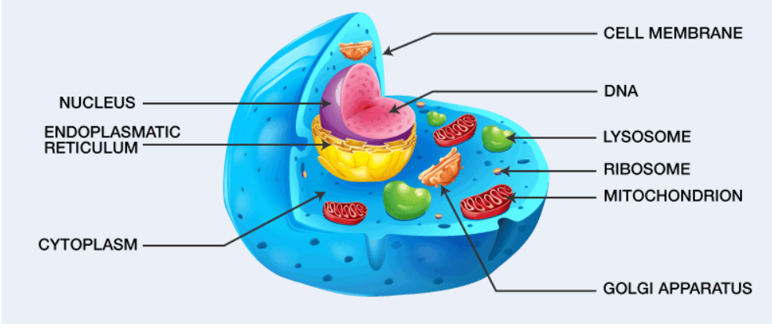
Cells are broadly categorized into two types:
- Prokaryotic cells: These cells are not fully developed; they have a less developed nucleus and some organelles (e.g., bacteria).

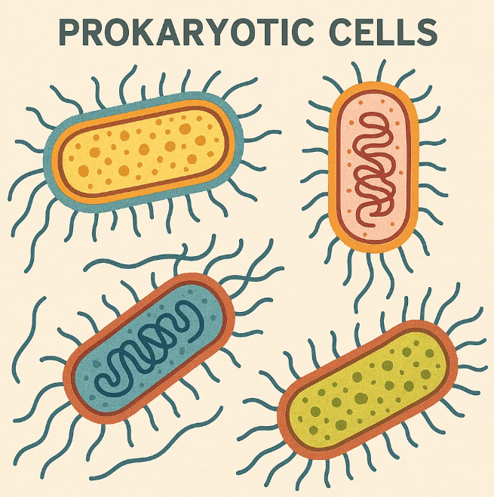
- Eukaryotic cells: These cells are fully developed with a well-developed nucleus and other organelles (e.g., plants, animals, fungi).
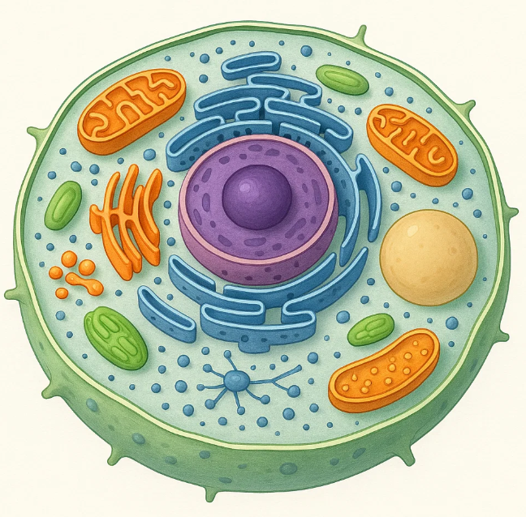
The major functions of a cell include:
- Movement of substances across the cell membrane.
- Cell growth and metabolism through cell division.
- Protein synthesis via transcription and translation.
The structure of a cell is primarily divided into three major parts:
- Plasma membrane
- Cytoplasm
- Nucleus
Plasma Membrane (Cell Membrane)
The plasma membrane, also known as the cell membrane, is the outermost membrane of the cell. It separates the internal environment of the cell from the external environment. This membrane is selectively permeable, allowing only certain substances to pass through it.
Structure: The fluid-mosaic model of the plasma membrane was proposed by S.T. Singer and G.L. Nicholson. It is composed of a bilayer of phospholipids embedded with proteins of various shapes and sizes.
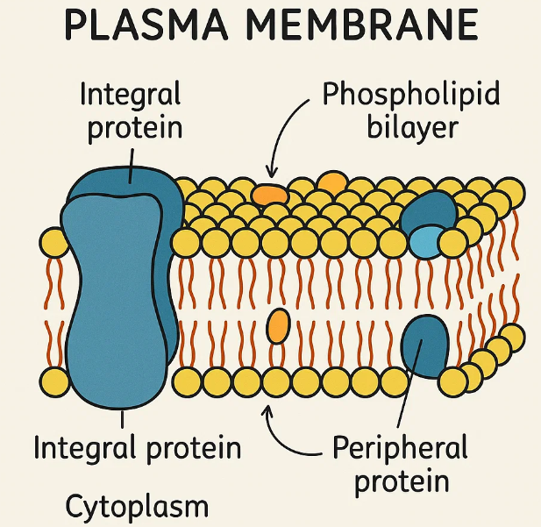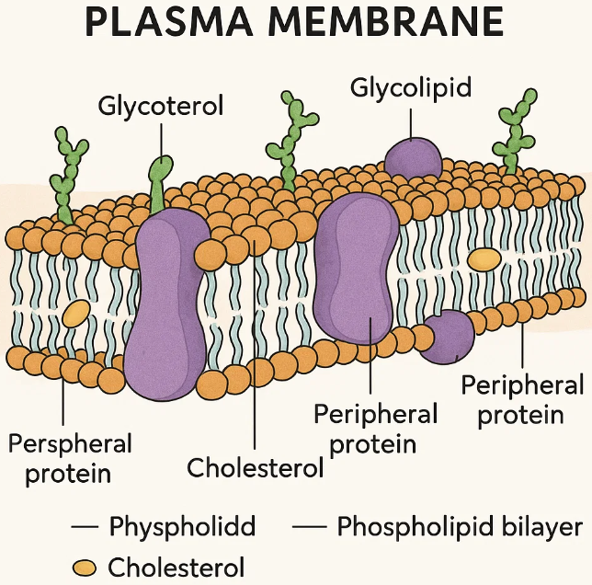
- Components: Phospholipid bilayer, Integral proteins (transmembrane), Peripheral proteins, Carbohydrates (attached to proteins as glycoproteins and to lipids as glycolipids).
Functions:
- Provides protection from the external environment.
- Gives shape to the cell.
- Regulates the flow of materials into and out of the cell.
- Plays a key role in communication with other cells and the external environment.
Cytoplasm
The cytoplasm is the total area between the plasma membrane and the nucleus. It is divided into two main parts:
- Cytosol: This is the fluid present inside the cells, transparent and viscous, containing 75-90% water, proteins, lipids, and carbohydrates.
- Organelles: These are structures present in the cytoplasm that perform specific functions for the cell.
Major Organelles:
- Endoplasmic Reticulum (ER): A complex channel system enclosed within a membrane, forming a three-dimensional network of vesicles, flattened sacs, and branched tubules.
  - Rough ER: Has ribosomes attached, involved in protein and membrane synthesis.
  - Smooth ER: Lacks ribosomes, helps in the synthesis of phospholipids, cholesterol, and triglycerides.
  - Functions: Acts as a structural framework of the cytoplasm and exchanges materials.
- Ribosomes: Tiny spheres made up of two subunits (40S smaller, 60S larger), forming an 80S complex. They contain ribosomal RNA and proteins.
  - Types: Some are attached to the ER, while others are free in the cytoplasm.
  - Functions: Known as protein factories, as protein synthesis occurs here.
- Mitochondria: Known as the "Power House of the cell" because they generate ATP. They have two membranes (inner and outer).
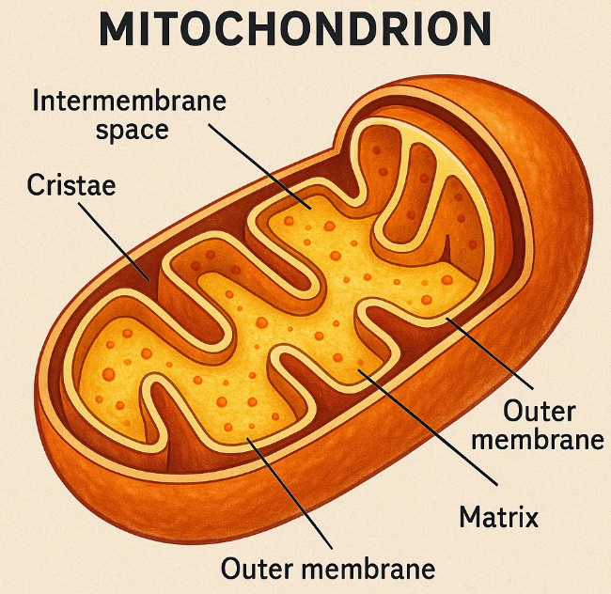
  - Functions: Generate energy, perform cellular signaling, and regulate cellular proliferation.
- Golgi Apparatus/Body: Consists of four to six flattened sacs called cisternae, stacked like a pile of plates with expanded bulges at their ends.
  - Functions: Stores and modifies proteins, and moves them to the plasma membrane via secretory granules when required. Also helps in excreting excess water.
- Lysosomes: Formed from the Golgi complex, they act as the "digestive system of the cell". They contain digestive and hydrolytic enzymes that break down large molecules like proteins, RNA, DNA, and lipids.
  - Functions: Vary in size (0.1-1.2 micrometers) and defend the body against microorganisms.
- Centrosomes: Consist of a pair of centrioles and play an important role during cell division.
- Peroxisomes: Contain many oxidase enzymes that oxidize various organic substances (fatty acids, amino acids, uric acid). They also contain catalase, an enzyme that protects cells against toxic effects of substances.
Nucleus
The nucleus is typically a spherical and oval-shaped structure, the largest organelle in the cell. It has a double membrane that separates it from the cytoplasm. It contains a spherical structure called the nucleolus.
Functions:
- Known as the "control centre of the cell".
- Contains genetic material (DNA, RNA, proteins).
- Directly involved in reproduction and transfers genetic information from parent to daughter cells.
Transport Across Membranes
The plasma membrane is selectively permeable, allowing only specific substances to cross. Substances move across the cell membrane via:
- Passive transport
- Active transport
- Endocytosis
Concentration Gradient
Substances move from an area of high concentration to an area of lower concentration. This movement is "across the concentration gradient". Movement against the concentration gradient (from low to high) requires energy.
Passive Transport
In passive transport, substances move across the concentration gradient (from high to low concentration) without the use of energy.
Types of Passive Transport:
- Passive Diffusion: The transport of substances across the concentration gradient from a region of higher concentration to a lower concentration without energy.
  - Examples: Diffusion of lipid-soluble molecules like O₂ and CO₂ across the cell membrane.
- Facilitated Diffusion: Substances are transported across the concentration gradient with the help of carrier bodies (carrier-mediated transport) or through aqueous protein channels.
  - Suitable for poorly diffusible substances.
  - Carriers used include Solute Carrier (SLC) transporters.
  - Examples: Entry of glucose into RBCs, intestinal absorption of Vitamins B₁ and B₂.
- Osmosis: The movement of solvent (water) particles from a high solvent concentration to a low solvent concentration through a semipermeable membrane (from low solute concentration to high solute concentration).
Active Transport
In active transport, substances are transported against the concentration gradient with the help of energy (ATP is used).
Types of Active Transport:
- Primary Active Transport: Uses ATP directly as an energy source.
  - Example: Absorption of glucose, Na⁺-K⁺ ATPase pump.
- Secondary Active Transport: Uses electrochemical gradients instead of direct ATP hydrolysis.
  - Symport (co-transport): Movement of both substances in the same direction (e.g., Na⁺-glucose symporter).
  - Antiport (counter-transport): Movement of molecules in opposite directions (e.g., Na⁺-H⁺ pump).
Endocytosis
In endocytosis, very large molecules are transported into the cell via engulfment by the cell membrane.
- Examples: Cellular uptake of macromolecules like fats, starch, oil-soluble vitamins (A, D, E, K), and drugs like insulin.
- Phagocytosis: "Cell eating," the uptake of solid particulates.
- Pinocytosis: "Cell drinking," the uptake of fluid solutes.

Cell Division
Cell division is the process by which a parent cell duplicates its genome and other cellular components, eventually dividing into two daughter cells. The newly formed cells have genetic content (DNA) that is exactly the same as the parent cell.
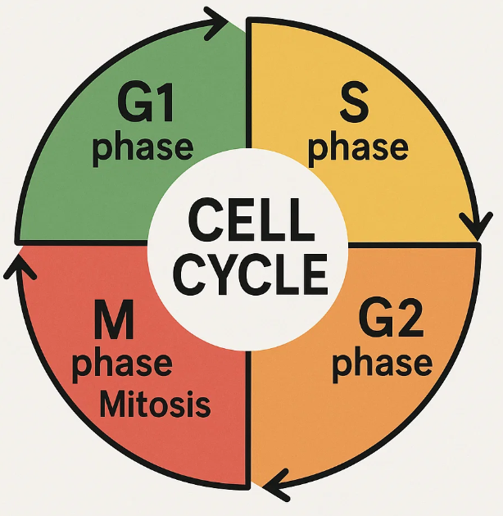
The cell cycle has two phases:

- Interphase: The preparation phase for cell division. It includes:
  - G₁ Phase (First Growth Phase): Cell growth, protein synthesis.
  - S Phase (Synthesis Phase): DNA replication, duplication of chromatin.
  - G₂ Phase (Second Growth Phase): Cell growth, RNA and protein synthesis.
- M-Phase (Cell Division): The phase where cell division occurs.
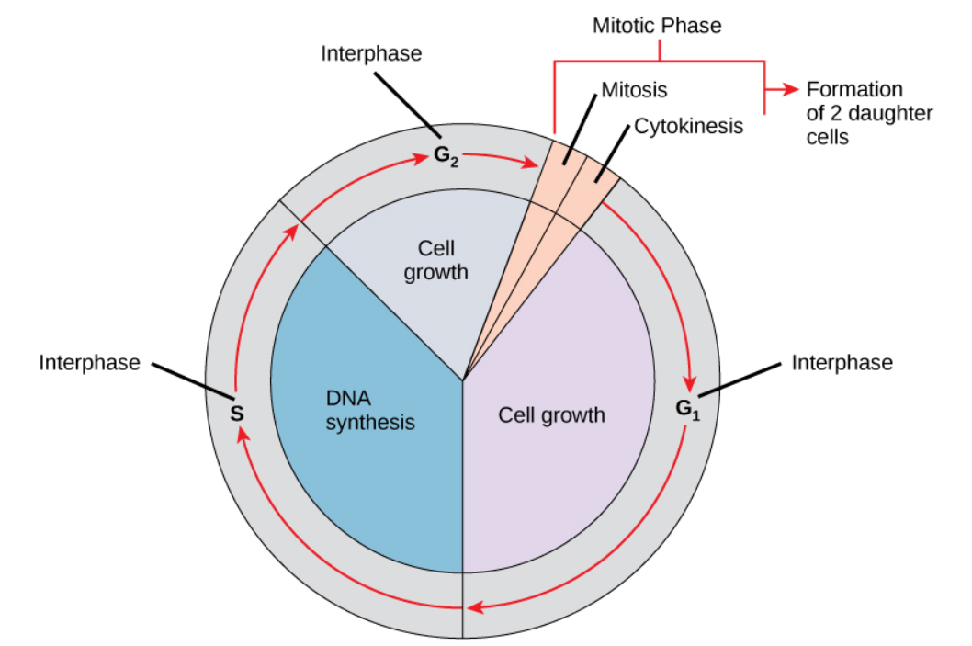
Cell division is of two types:
- Mitosis: Responsible for the growth of cells and occurs in somatic cells. In mitosis, the number of chromosomes remains the same as the parent cell (equational division), producing two identical daughter cells.
  - Also known as M-phase or Mitotic phase.
  - Karyokinesis: Division of the nucleus. It occurs in four stages:
    - Prophase: Begins with the initiation of chromatin condensation. Centrioles move to opposite poles, nuclear envelope disappears, and organelles like Golgi complex and ER also disappear.
    - Metaphase: Chromosomes move to the spindle equator and align. Spindle fibers attach to kinetochores (small disc-shaped structures on the surface of chromosomes).
    - Anaphase: Begins with the splitting of centromeres, and sister chromatids move towards opposite poles of the cell.
    - Telophase: Chromosomes lose their individuality and decondense. Nuclear membrane reforms, and two nuclei are formed.
  - Cytokinesis: Division of the parent cell's cytoplasm after nuclear division to form two daughter cells.
- Meiosis: Occurs in reproductive cells (gamete cells) and is responsible for the formation of gamete cells. In meiosis, the number of chromosomes is reduced (reductional division). Offspring are produced by the fusion of female gamete (egg, n chromosomes) and male gamete (sperm, n chromosomes) to form a zygote (2n chromosomes).
  - It occurs in two stages: Meiosis-I and Meiosis-II.
  - Meiosis-I: Divided into four phases and is longer and more complex than mitosis.
    - Prophase-I: Further subdivided into five sub-phases:
      - Leptotene phase: Condensation of chromosomes.
      - Zygotene phase: Pairing of homologous chromosomes (synapsis) occurs, forming bivalents/tetrads.
      - Pachytene phase: Exchange of genetic material between two homologous chromosomes (crossing over) occurs.
      - Diplotene phase: Dissolution of the synaptonemal complex and formation of X-shaped structures called chiasmata.
      - Diakinesis phase: Terminalization of chiasmata, complete chromosomal condensation, and disappearance of the nuclear envelope.
    - Metaphase-I: Homologous chromosomes align at the equatorial plate.
    - Anaphase-I: Separation of homologous chromosomes, which move towards opposite poles.
    - Telophase-I: Chromosomes decondense, nuclear membrane reforms, and two haploid daughter cells are formed. This is followed by cytokinesis.
  - Meiosis-II: Similar to normal mitosis and also consists of four stages:
    - Prophase-II: Chromosomes condense, and the nuclear membrane disappears.
    - Metaphase-II: Chromosomes align at the equatorial plate.
    - Anaphase-II: Sister chromatids separate and move to opposite poles.
    - Telophase-II: Chromosomes decondense, nuclear envelope reassembles, and nucleolus reappears. This phase is followed by cytokinesis, resulting in four haploid daughter cells (gametes).

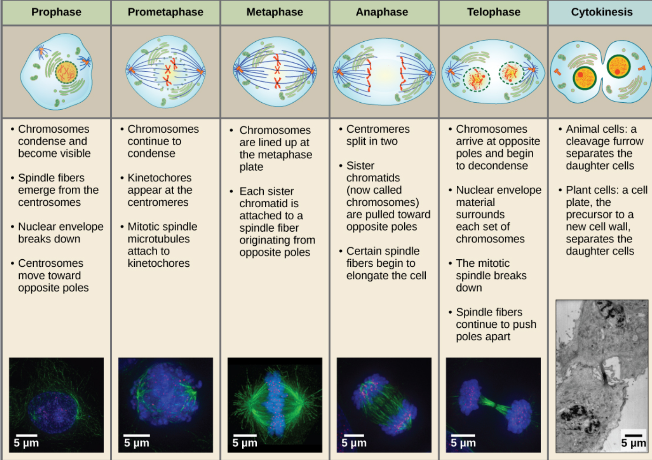
Cell Junctions
Cell junctions are contacts between neighboring cells that help maintain the paracelluar barrier and prevent the movement of unwanted water and solutes. They also facilitate communication between cells.
Cell junctions are divided into five main types:
- Tight Junctions (Zonula Occludens):
  - Function: Seal adjacent cells, preventing leakage of fluids and unwanted substances between them. They provide a strong mechanical attachment.
  - Location: Mostly found in epithelial tissue, including organs like the skin, blood vessels, and urinary bladder.
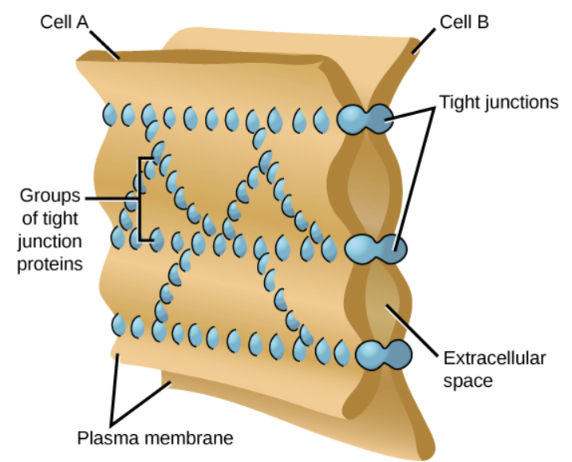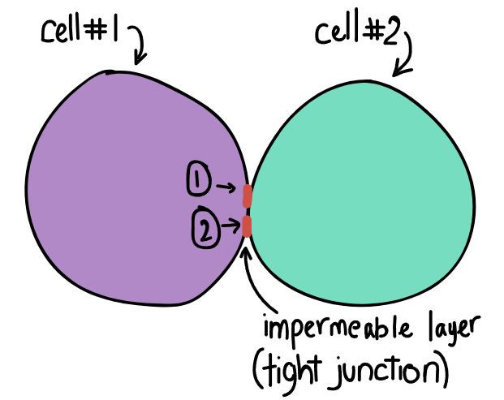
- Adherens Junctions (Zonula Adherens):
  - Function: Provide strong adhesion between cells through the linkage of actin filaments to cytoplasmic plaques. They prevent the separation of cells and provide strength.
  - Components: Made up of multiple proteins that also provide strength to the cells.
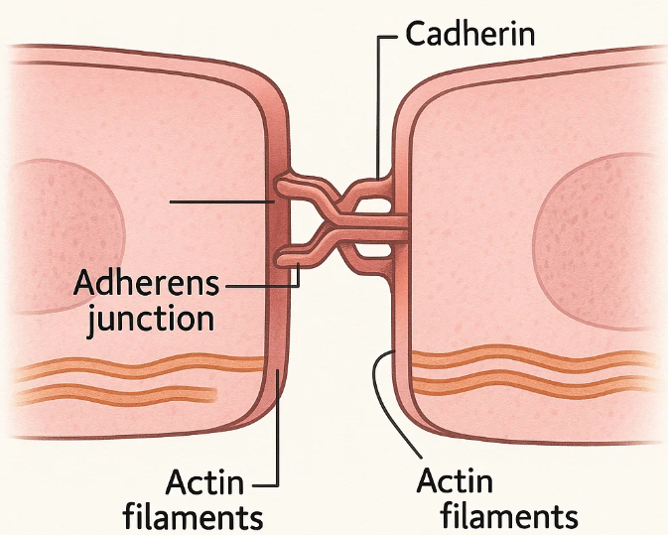
- Desmosomes (Macula Adherens):
  - Function: Spot-like adhesive junctions that prevent the separation of cells by holding them tightly together using proteins like desmoglein. They provide strong adhesion.
  - Components: Contain keratin filaments (intermediate filaments).
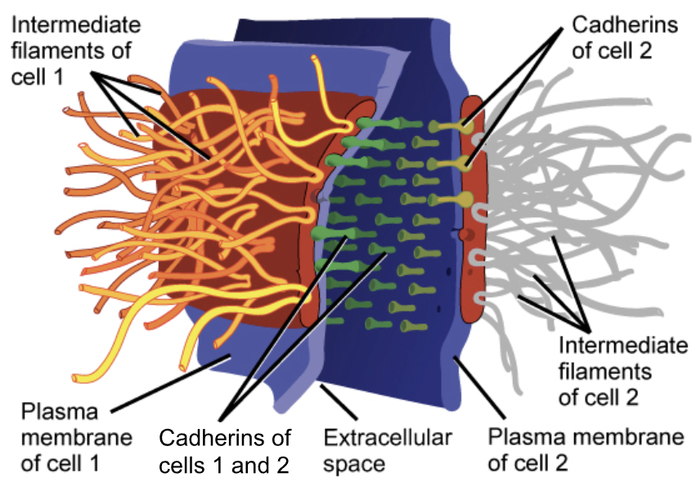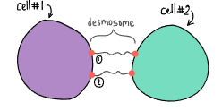
- Hemidesmosomes:
  - Function: An adhesive junction that connects the cell to the basement membrane of epithelial tissue.
  - Location: Found in epithelial cells.
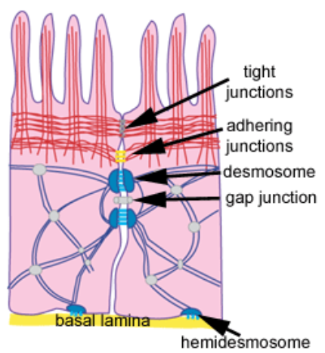
- Gap Junctions (Nexus / Cell-Cell Channels):
  - Function: Allow rapid transfer of small molecules, nutrients, and electrical signals between adjacent cells by forming channels (connexons).
  - Location: Found between adjacent cardiac and smooth muscle cells, enabling the conduction of electrical signals.
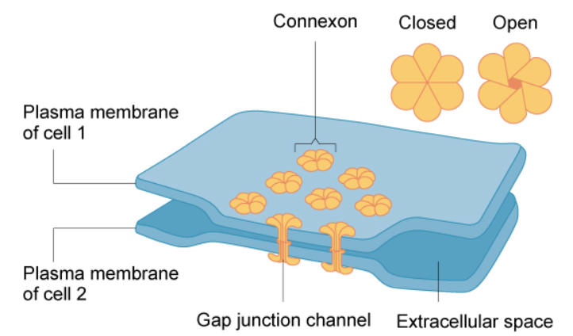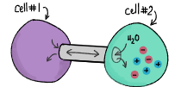
Cell Communication
Cell communication refers to how cells transmit, receive, and process signals from other cells or from themselves. It is important for maintaining homeostasis and for the growth and development of cells.
Cell communication is broadly divided into two types:
- Intercellular Signaling (Extracellular Signaling): Refers to communication between different cells.
  - Signalling molecules (ligands) are produced by a signalling cell and recognized by receptors on a target cell. These signals are then transduced into intracellular signals.
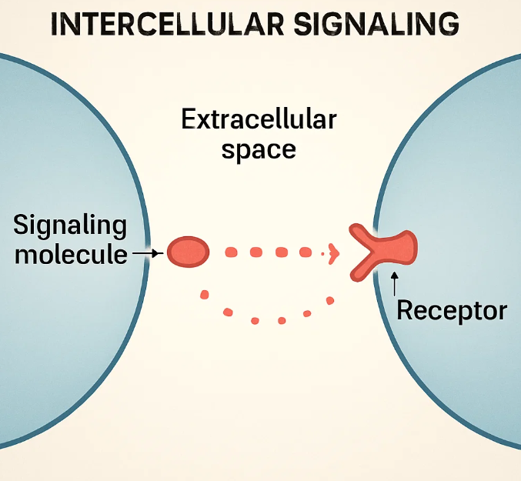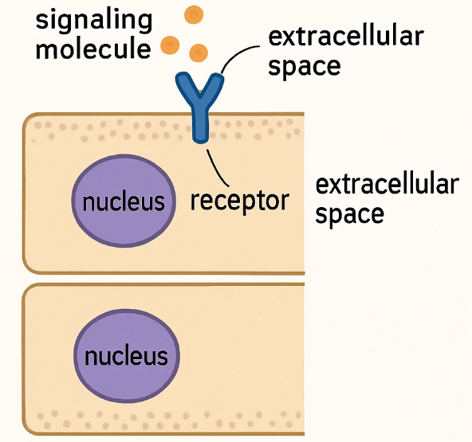
  - Types of Intracellular Signalling activated by Extracellular Signal Molecules:
- Contact-Dependent Signalling: One cell is directly in contact with another cell through membrane-to-membrane contact.
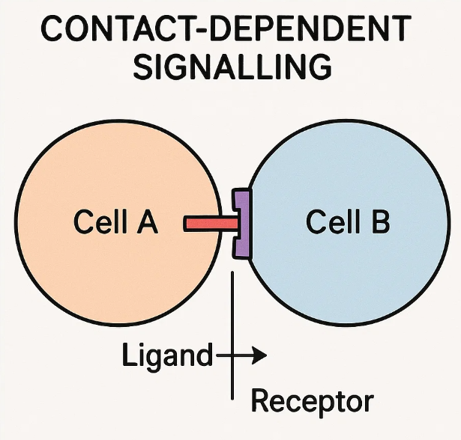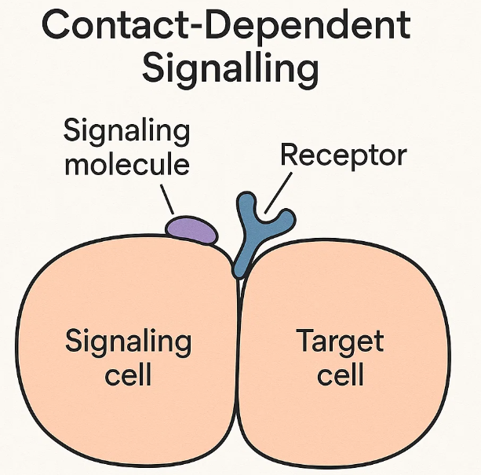
- Paracrine Signalling: Signalling molecules produced by a signalling cell act on nearby target cells. This type of signalling is involved in inflammation and the initiation of immune responses.
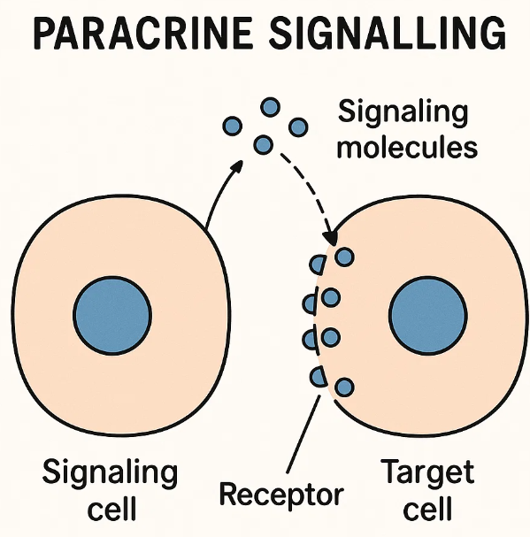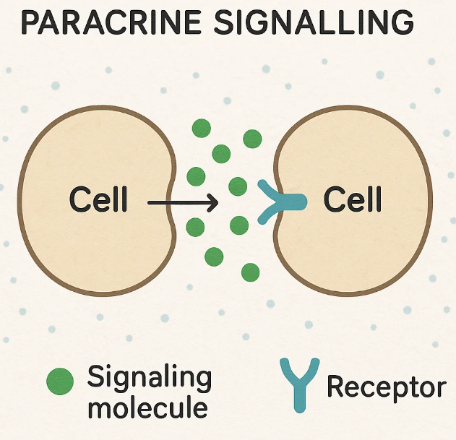
- Synaptic Signalling: Involves neurotransmitters released from neurons that bind to receptors on target cells (e.g., muscle cells or other neurons). This is a type of juxtracrine signalling (electrical and chemical).
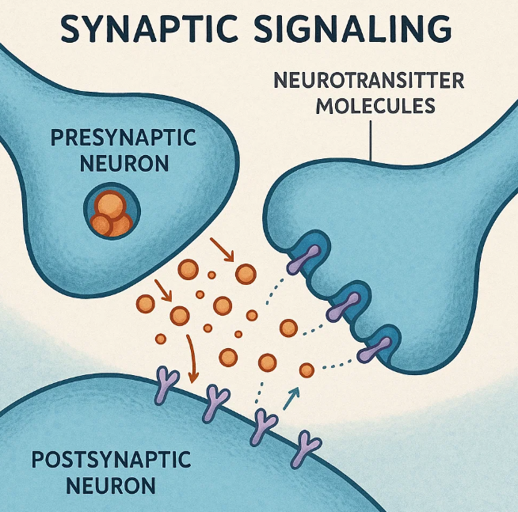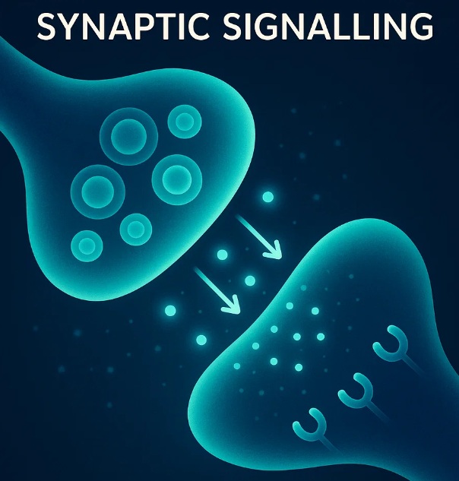
- Endocrine Signalling: Signalling molecules (hormones) are released into the bloodstream and travel to distant target cells.
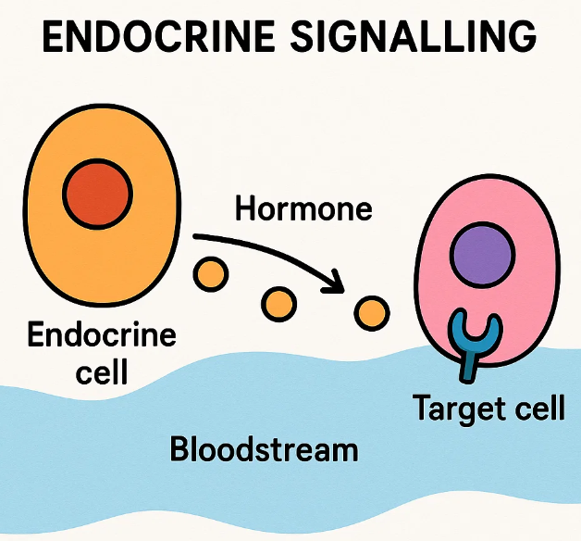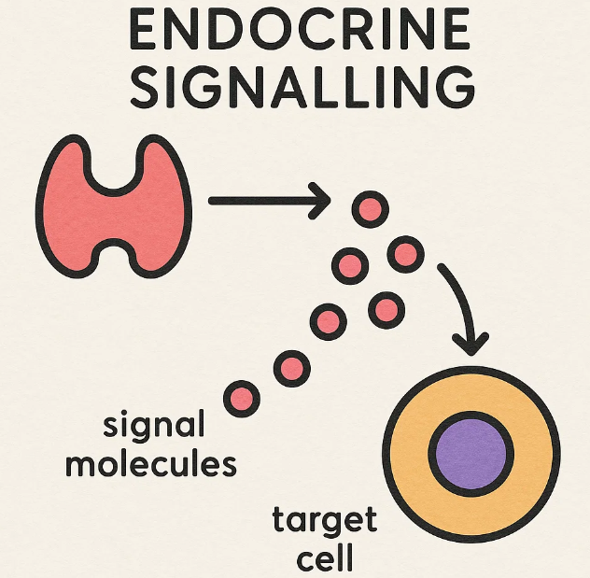

- Intracellular Signalling: Refers to communication within the same cell.
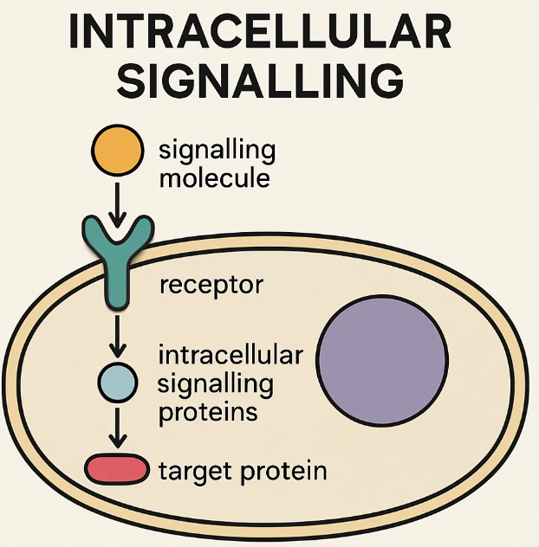
  - This pathway involves various signalling chains. The receptor activates and gives a response to the cell. Secondary messengers (e.g., cAMP, DAG, IP₃) are often involved in signal transduction.
  - Intracellular signalling is completed in three steps: Reception, Transduction, and Response.
Human Anatomy and Physiology - I:
Chapter 3 - Tissue Level of Organisation
Classification of Tissue
"Tissues are classified into four major types based on their structure and functions".
- Tissue: "It is a group of some cells which have Similar structure and functions".
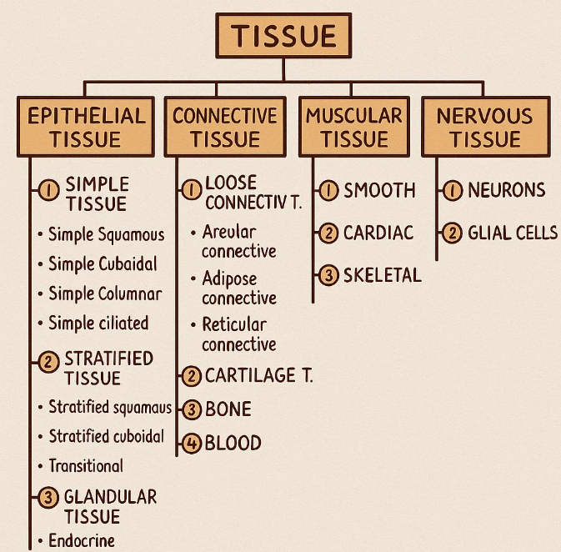
- Epithelial tissue: "provides covering and protection to the body".
- Connective tissue: "provides structural framework to the body".
- Muscular tissue: "provides movement to body".
- Nervous tissue: "responsible for coordination and communication".
Functions of Tissue:
- "They are only found in multicellular organism".
- "All tissue together performs the functions to Support the body system".
- "Tissue provides shape to the body and help body to store energy".
- "Tissue helps in the formation of various organs. Heart, kidney, lungs etc..".
- Histology: "It is the branch of science that deals with the study of tissue".
Types of Tissues
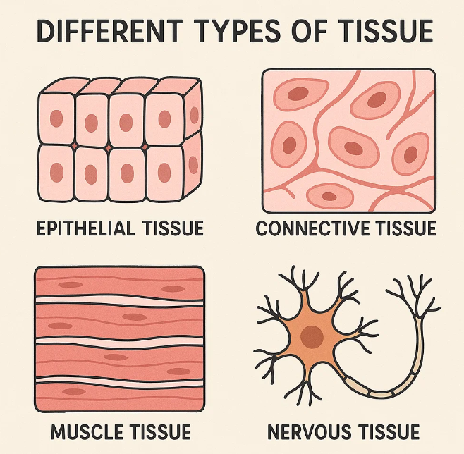
1. Epithelial Tissues
Also known as 'Vascular tissue' or 'Epithelium'.
- "These are those tissue which are made up of closely packed cells and form continuous sheet".
- "They contain minimal extracellular space but they are arranged on basement membrane which is made up by thin sheet of connective tissue".
- "They mainly form outer covering of skin/body and internal organs like kidney, lungs, glands etc.".
Functions of Epithelial Tissue:
- "They provide covering to our body and various internal organs".
- "They provide protection to our body from mechanical injury, harmful chemicals, loss of water".
- "They help in secretion of various hormones and chemicals through glands".
- "They help in absorption of nutrients from food".
- "They also help in excretion of waste products".
Classification of Epithelial Tissue based on Structure:
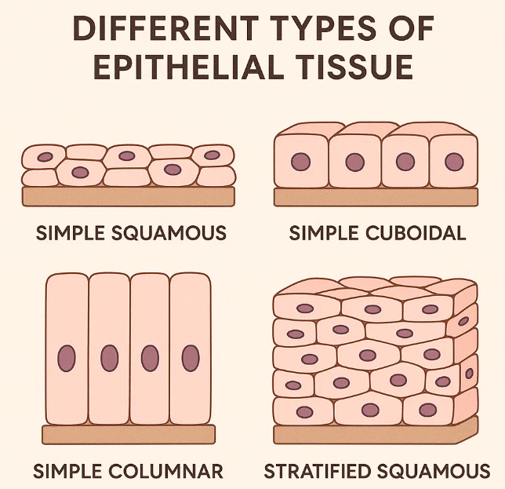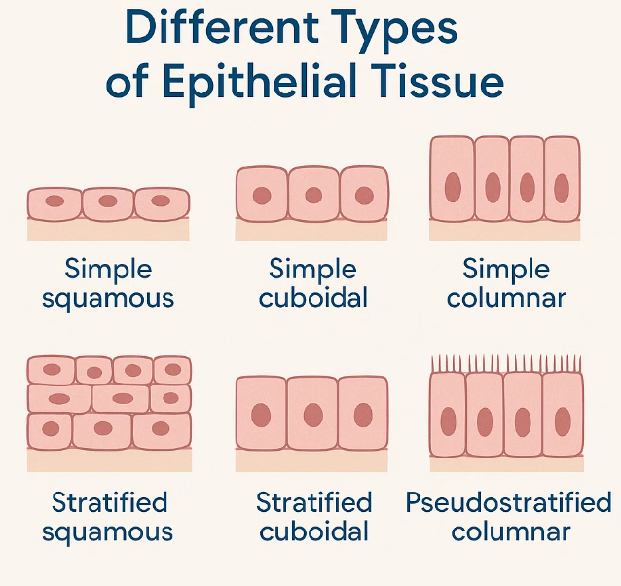
- Simple Epithelial Tissue: "These are those tissue which are made up with single layer of cells".
  - Simple Squamous Epithelium: "It is made up of only a single layer of flat, scale like cells".
    - Nucleus: "the nucleus of each cell is oval /spherical".
    - Location: "Heart, blood vessels, Lymphatic vessels, Airsacs) of lungs, Lining of kidney".
    - Functions: "Blood filtration in kidney, Diffusion of Os to blood vessels, exchanges of gaser [O2/CO₂], secreting substances".
  - Simple Cuboidal Epithelium: "It is made up of a single layer of cube shape cells, that rest on a basement membrane".
    - Location: "Surface of ovary lines, kidney tubules, thyroid glands, duch of many glands".
    - Functions: "provide mechanical support, secretion and excretion".
  - Simple Columnar Epithelium: "It is made up of single layer of rectangular cells arranged on basement membrane".
    - "It contain goblet cells, cilia and microvilli".
    - Location: "lining of stomach, intestine, uterus, uterine tubes and some parts of respiratory tract".
    - Functions: "secretion and absorption excretion and protection".
  - Simple Ciliated Epithelium: Also known as pseudostratified columnar epithelium.
    - "It is made up of only a single layer and have irregularly shaped Columnar cells".
    - Location: "few portion of upper respiratory tract, ventricles of the brain, spinal cord".
    - Functions: "protection and secretion, moves mucus and other substances by cilliary action".
- Stratified Epithelial Tissue: "These are those tissue in which cells are arranged in multiple layers. i.e. one over another".
  - Stratified Squamous Epithelium: "It is made up of multiple layers of flattened squamous cells".
    - Location: "Skin, Oesophages, pharynx, lining of mouth, tongue, vagina".
    - Types:
      - Keratinised: "contain keratin fibres, provides protective qualities to the skin".
      - Non-keratinised: "it remain moist, such as vagina, mouth and oesophagus".
  - Stratified Cuboidal Epithelium: "It is made up of two or more layers of cube shaped cells".
    - Location: "Sweat gland, Salivary glands and mammary glands".
    - Functions: "Protection, Secretion of saliva, sweat, and milk".
  - Stratified Columnar Epithelium: "It is made up of multiple layer of rectangular shaped cells".
    - Location: "Urethra, Oesophageal gland, mucus membrane, Lining of eyelids".
    - Functions: "Protection and secretion".
  - Transitional Epithelium: "It is presented at the sites which are subjected to changes in stress and tension".
    - Location: "urinary bladders, their lining".
    - Functions: "provide contraction".
2. Glandular Epithelium
"These are those tissue which are used for their secretion action, in which they excrete various hormones and chemicals".
- "They secreted into ducts, surface of the body, or directly into the blood".
- Connective Tissue Connective tissue is a type of tissue that supports, binds, protects, and connects other tissues and organs in the body. It is made up of cells, fibers, and a ground substance (matrix).
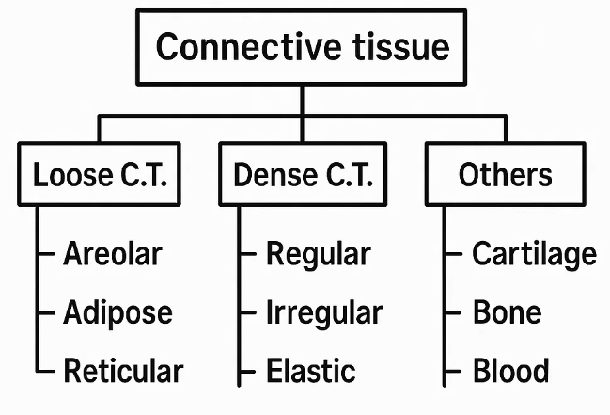
- Loose Connective Tissue
  - Areolar connective
  - Adipose connective
  - Reticular connective
- Dense Connective Tissue
  - Dense regular
  - Dense irregular
  - Elastic
- Cartilage
- Bone
- Blood 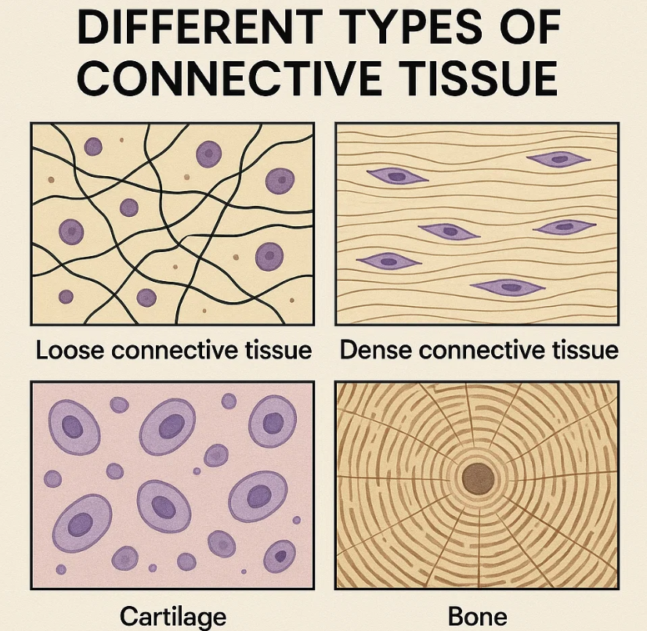 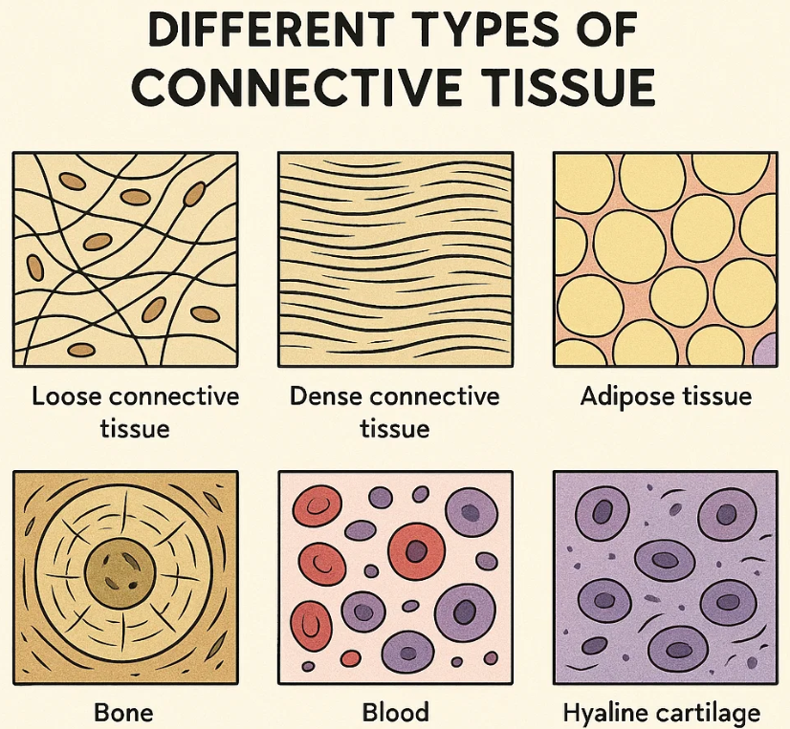

🔹 Types of Connective Tissue:
I. Loose Connective Tissue:
Loose connective tissue has more ground substance and fewer fibers. It fills spaces between organs and supports epithelium.
1. Areolar Connective Tissue
- Location: Beneath skin, around blood vessels and nerves
- Function: Binds skin to muscles, cushions organs, provides nutrients
- Structure: Contains collagen, elastic fibers, fibroblasts, and immune cells
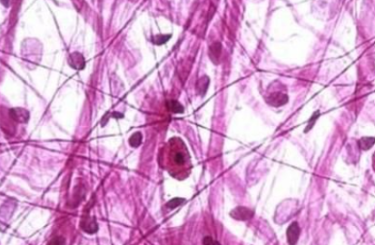
2. Adipose Connective Tissue
- Location: Under skin, around kidneys, heart, eyeballs
- Function: Stores fat, insulates the body, cushions organs
- Structure: Contains large fat-filled cells called adipocytes
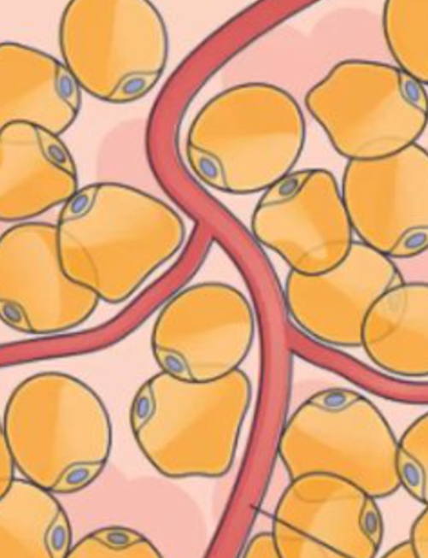
3. Reticular Connective Tissue
- Location: Liver, spleen, lymph nodes, bone marrow
- Function: Forms a supportive framework (stroma) for soft organs
- Structure: Contains reticular fibers and cells
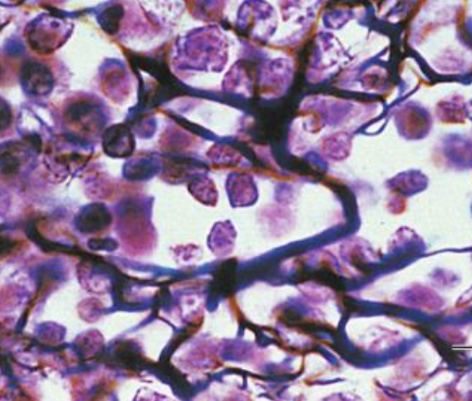

II. Dense Connective Tissue:
Dense connective tissue contains more collagen fibers and provides strength and support.
1. Dense Regular Connective Tissue
- Location: Tendons (connect muscle to bone), ligaments (connect bone to bone)
- Function: Provides strong, rope-like resistance to pulling forces
- Structure: Parallel bundles of collagen fibers
2. Dense Irregular Connective Tissue
- Location: Dermis of skin, joint capsules, around organs
- Function: Withstands tension from different directions
- Structure: Collagen fibers arranged irregularly
3. Elastic Connective Tissue
- Location: Walls of arteries, lungs, vocal cords
- Function: Allows stretching and recoil
- Structure: Mainly elastic fibers with some collagen

III. Specialized Connective Tissues:
1. Cartilage
- Types: Hyaline, Elastic, Fibrocartilage
- Location: Joints, nose, ear, trachea, intervertebral discs
- Function: Provides flexible support and cushioning
- Structure: Cells (chondrocytes) in spaces called lacunae, surrounded by firm matrix
2. Bone (Osseous Tissue)
- Location: Skeleton (bones of the body)
- Function: Supports the body, protects organs, stores minerals, makes blood cells
- Structure: Hard matrix of calcium salts, cells called osteocytes
3. Blood
- Location: Circulates in blood vessels
- Function: Transports oxygen, nutrients, hormones, and removes waste
- Structure: Fluid matrix (plasma) with red blood cells, white blood cells, and platelets

4. Muscular Tissue
Muscular tissue is a specialized tissue that helps in movement of body parts by contracting and relaxing. It is made up of elongated cells called muscle fibers and is responsible for body movement, posture, and vital functions like heartbeat and digestion.

Types of Muscular Tissue:
- Skeletal Muscle: Muscular tissue is a type of body tissue made up of muscle fibres that can contract and relax to produce movement. It is responsible for movement, posture, and vital body functions like heartbeat and digestion.
  - Voluntary (under conscious control)
  - Striated (has stripes)
  - Attached to bones
  - Helps in body movement
- Cardiac Muscle: Cardiac muscle is a specialized, involuntary, striated muscle found only in the walls of the heart. It is responsible for the rhythmic contraction of the heart to pump blood throughout the body.
  - Involuntary
  - Striated and branched
  - Found only in the heart
  - Responsible for pumping blood
- Smooth Muscle: Smooth muscle is an involuntary, non-striated muscle found in the walls of internal organs. It controls automatic, slow movements such as digestion, blood flow, and urination.
  - Involuntary
  - Non-striated
  - Found in walls of internal organs (stomach, blood vessels, uterus, etc.)
  - Controls internal movements like digestion and blood flow

Functions of Muscular Tissue:
- Movement of body and internal organs
- Maintain posture and body position
- Circulation of blood (heart)
- Movement of food in digestive tract (peristalsis)
- Control of pupil size, urination, and childbirth

- Nervous Tissue
These are those which are found in the brain, spinal cord and nerves and are responsible for coordinating and controlling many body activities.
- The main function of nervous tissue is to receive information from stimuli, analyze with brain/spinal cord and send response.
- FUNCTIONS:
• Responsible for coordination and communications.
• Regulate and controls body functions.
• Send and receive impulses (information).
• Stimulates muscle contraction
• Play major role in emotions, memory.
  - Neurons / Nerve Cells:
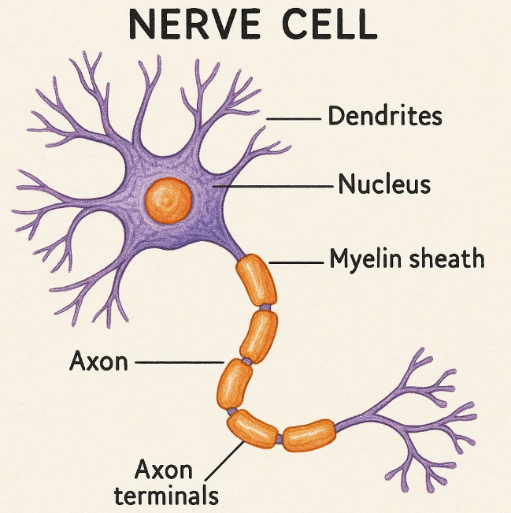
It is the structural and functional unit of nervous tissue. It is responsible for all the functions provided by nervous tissue.
It contains various parts
Cell body = main body, contains nucleus & dendrites.
Dendrites = Branches, receive signals & pass.

  - Neuroglial / Glial cells:
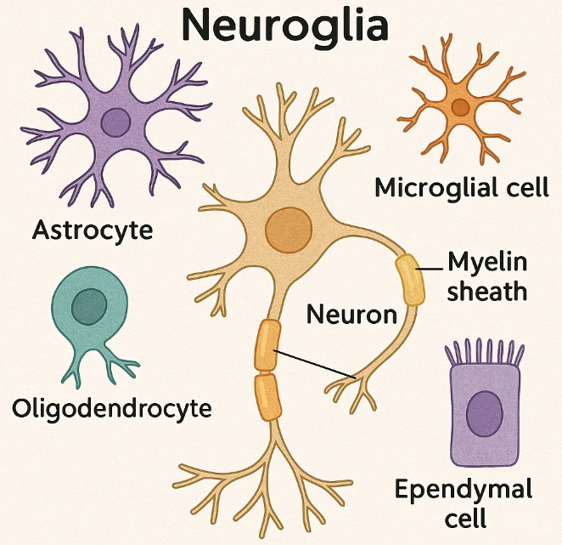
- These are supporting cells which provide, connect, support and regulate the functioning of neurons.
- It is of three types –
• Astrocytes – regulate the functions and protection
• Microglia – destroy pathogens
• Oligodendrocytes – enhance conduction speed.

